Ch7 Problems

Zachary Sisco

1. Write the SQL code required to list the employee number, last name, first name, and middle initial of all employees whose last names start with *Smith*. In other words, the rows for both Smith and Smithfield should be included in the listing. Sort the results by employee number. Assume case sensitivity.

SELECT *

FROM EMPLOYEE

WHERE UPPER(EMP_LNAME) LIKE 'SMITH%'

ORDER BY EMP_NUM;

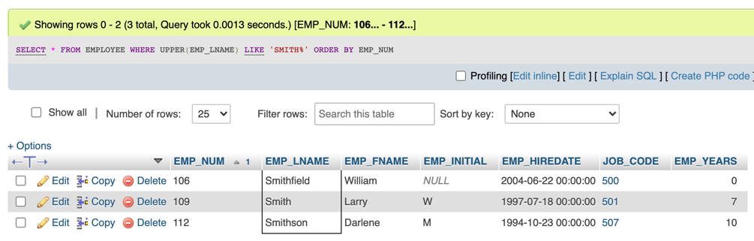

1. Using the EMPLOYEE, JOB, and PROJECT tables in the Ch07_ConstructCo data- base, write the SQL code that will join the EMPLOYEE and PROJECT tables using EMP_NUM as the common attribute. Display the attributes shown in the results presented in Figure P7.2, sorted by project value.

SELECT PROJ_NAME, PROJ_VALUE, PROJ_BALANCE, EMP_LNAME, EMP_FNAME, EMP_INITIAL, JOB.JOB_CODE, JOB_DESCRIPTION, JOB_CHG_HOUR

FROM PROJECT JOIN EMPLOYEE ON PROJECT.EMP_NUM = EMPLOYEE.EMP_NUM JOIN JOB ON EMPLOYEE.JOB_CODE = JOB.JOB_CODE

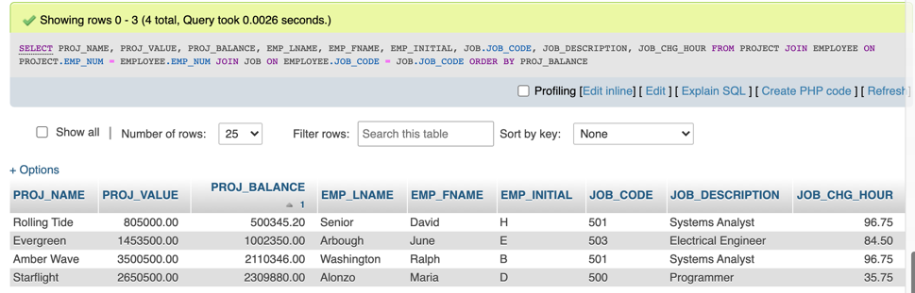ORDER BY PROJ_BALANCE;

1. Write the SQL code that will produce the same information that was shown in Problem 2, but sorted by the employee’s last name.

SELECT PROJ_NAME, PROJ_VALUE, PROJ_BALANCE, EMP_LNAME, EMP_FNAME, EMP_INITIAL, JOB.JOB_CODE, JOB_DESCRIPTION, JOB_CHG_HOUR

FROM PROJECT JOIN EMPLOYEE ON PROJECT.EMP_NUM = EMPLOYEE.EMP_NUM JOIN JOB ON EMPLOYEE.JOB_CODE = JOB.JOB_CODE

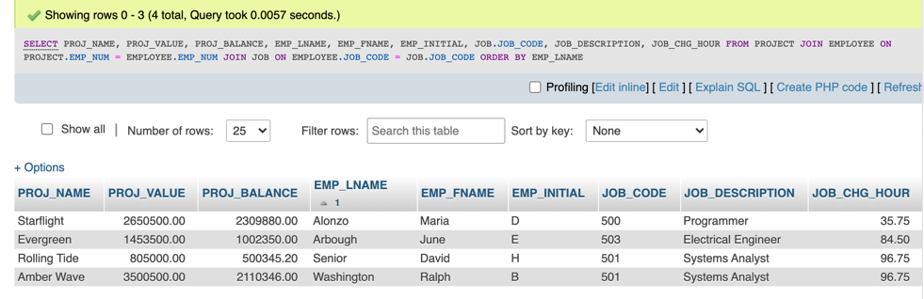ORDER BY EMP_LNAME;

1. 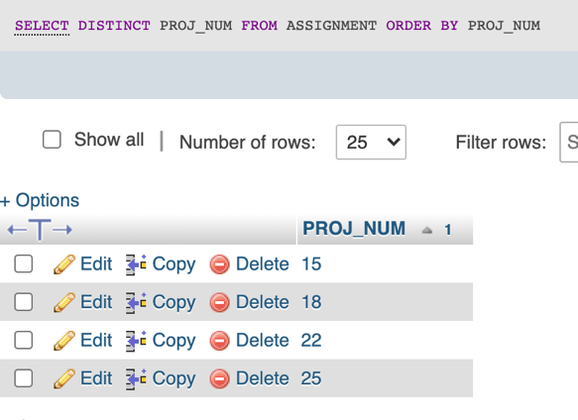Write the SQL code that will list only the distinct project numbers in the ASSIGN- MENT table, sorted by project number.

SELECT DISTINCT PROJ_NUM

FROM ASSIGNMENT

ORDER BY PROJ_NUM

1. 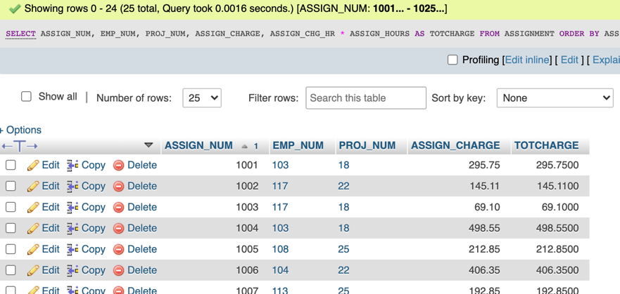Write the SQL code to validate the ASSIGN_CHARGE values in the ASSIGN- MENT table. Your query should retrieve the assignment number, employee num- ber, project number, the stored assignment charge (ASSIGN_CHARGE), and the calculated assignment charge (calculated by multiplying ASSIGN_CHG_HR by ASSIGN_HOURS). Sort the results by the assignment number.

SELECT ASSIGN_NUM, EMP_NUM, PROJ_NUM, ASSIGN_CHARGE, ASSIGN_CHG_HR * ASSIGN_HOURS AS TOTCHARGE

FROM ASSIGNMENT

ORDER BY ASSIGN_NUM;

1. Using the data in the ASSIGNMENT table, write the SQL code that will yield the total number of hours worked for each employee and the total charges stemming from those hours worked, sorted by employee number. The results of running that query are shown in Figure P7.6.

SELECT EMPLOYEE.EMP_NUM, EMP_LNAME, SUM(ASSIGN_HOURS) AS SumOfASSIGNHOURS, SUM(ASSIGN_CHARGE) AS SumOfASSIGNCHARGE

FROM EMPLOYEE JOIN ASSIGNMENT ON EMPLOYEE.EMP_NUM = ASSIGNMENT.EMP_NUM

GROUP BY EMP_NUM

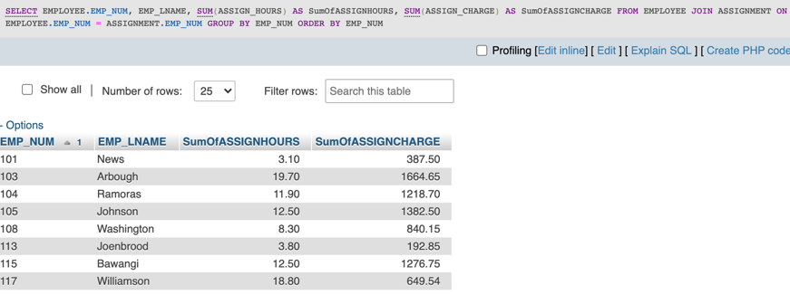ORDER BY EMP_NUM;

1. Write a query to produce the total number of hours and charges for each of the proj- ects represented in the ASSIGNMENT table, sorted by project number. The output is shown in Figure P7.7.

SELECT PROJ_NUM, SUM(ASSIGN_HOURS) AS SumOfASSIGNHOURS, SUM(ASSIGN_CHARGE) AS SumOfASSIGNCHARGE

FROM ASSIGNMENT

GROUP BY PROJ_NUM

ORDER BY PROJ_NUM;

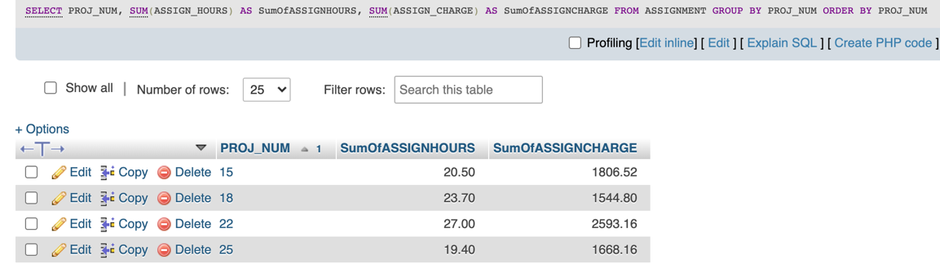

1. Write the SQL code to generate the total hours worked and the total charges made

by all employees. The results are shown in Figure P7.8.

SELECT SUM(ASSIGN_HOURS) AS SumOfSumOfASSIGN, SUM(ASSIGN_CHARGE) AS SumOfSumOfASSIGNCHARGE

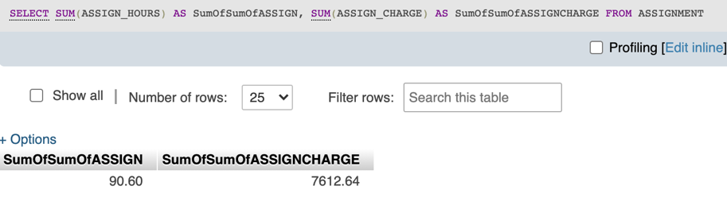FROM ASSIGNMENT;

1. 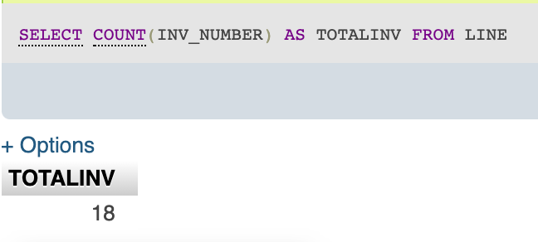Write a query to count the number of invoices.

SELECT COUNT(INV_NUMBER) AS TOTALINV

FROM LINE;

1. Write a query to count the number of customers with a balance of more than $500

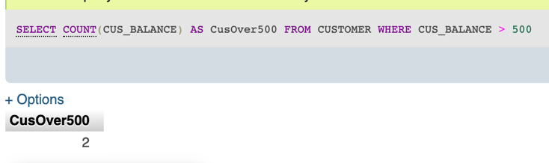SELECT COUNT(CUS_BALANCE) AS CusOver500

FROM CUSTOMER

WHERE CUS_BALANCE > 500;

1. Generate a listing of all purchases made by the customers, using the output shown in Figure P7.11 as your guide. Sort the results by customer code, invoice number, and product description.

SELECT CUS_CODE, INVOICE.INV_NUMBER, INV_DATE, P_DESCRIPT, LINE_UNITS, LINE_PRICE

FROM INVOICE JOIN LINE ON INVOICE.INV_NUMBER = LINE.INV_NUMBER JOIN PRODUCT ON LINE.P_CODE = PRODUCT.P_CODE

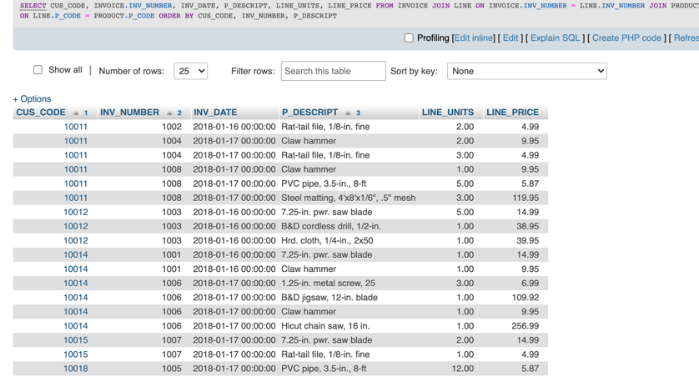ORDER BY CUS_CODE, INV_NUMBER, P_DESCRIPT;

1. Using the output shown in Figure P7.12 as your guide, generate a list of customer purchases, including the subtotals for each of the invoice line numbers. The subtotal is a derived attribute calculated by multiplying LINE_UNITS by LINE_PRICE. Sort the output by customer code, invoice number, and product description. Be certain to use the column aliases as shown in the figure.

SELECT CUS_CODE, INVOICE.INV_NUMBER, P_DESCRIPT, LINE_UNITS AS Units_Bought, LINE_PRICE AS Unit_Price, LINE_UNITS * LINE_PRICE AS Subtotal

FROM INVOICE JOIN LINE ON INVOICE.INV_NUMBER = LINE.INV_NUMBER JOIN PRODUCT ON LINE.P_CODE = PRODUCT.P_CODE

ORDER BY CUS_CODE, INV_NUMBER, P_DESCRIPT;

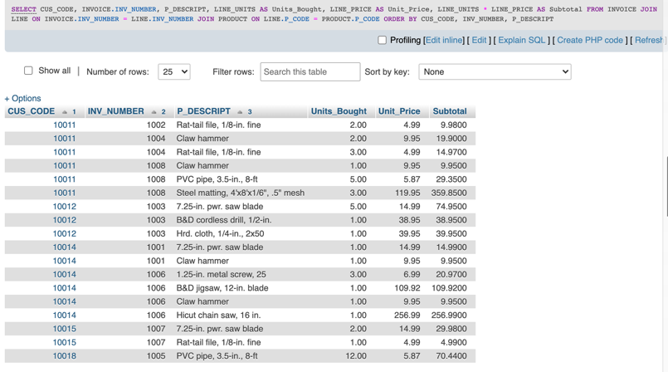

1. Write a query to display the customer code, balance, and total purchases for each customer. Total purchase is calculated by summing the line subtotals (as calculated in Problem 12) for each customer. Sort the results by customer code, and use aliases as shown in Figure P7.13.

SELECT CUSTOMER.CUS_CODE, CUS_BALANCE, SUM(LINE_UNITS*LINE_PRICE) AS TotalPurchases

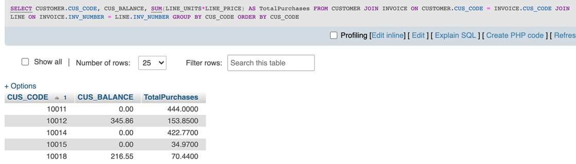FROM CUSTOMER JOIN INVOICE ON CUSTOMER.CUS_CODE = INVOICE.CUS_CODE JOIN LINE ON INVOICE.INV_NUMBER = LINE.INV_NUMBER

GROUP BY CUS_CODE

ORDER BY CUS_CODE;

1. Modify the query in Problem 13 to include the number of individual product pur- chases made by each customer. (In other words, if the customer’s invoice is based on three products, one per LINE_NUMBER, you count three product purchases. Note that in the original invoice data, customer 10011 generated three invoices, which contained a total of six lines, each representing a product purchase.) Your output values must match those shown in Figure P7.14, sorted by customer code.

SELECT CUSTOMER.CUS_CODE, CUS_BALANCE, SUM(LINE_UNITS*LINE_PRICE) AS TotalPurchases, COUNT(LINE_UNITS) AS NumberOfPurchases

FROM CUSTOMER JOIN INVOICE ON CUSTOMER.CUS_CODE = INVOICE.CUS_CODE JOIN LINE ON INVOICE.INV_NUMBER = LINE.INV_NUMBER

GROUP BY CUS_CODE

ORDER BY CUS_CODE;

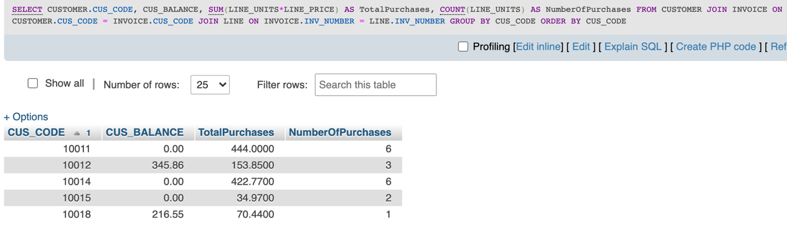

1. Use a query to compute the total of all purchases, the number of purchases, and the average purchase amount made by each customer. Your output values must match those shown in Figure P7.15. Sort the results by customer code.

SELECT CUSTOMER.CUS_CODE, CUS_BALANCE, SUM(LINE_UNITS*LINE_PRICE) AS TotalPurchases, COUNT(LINE_UNITS) AS NumberOfPurchases, AVG(LINE_UNITS*LINE_PRICE) AS AveragePurchaseAmount

FROM CUSTOMER JOIN INVOICE ON CUSTOMER.CUS_CODE = INVOICE.CUS_CODE JOIN LINE ON INVOICE.INV_NUMBER = LINE.INV_NUMBER

GROUP BY CUS_CODE

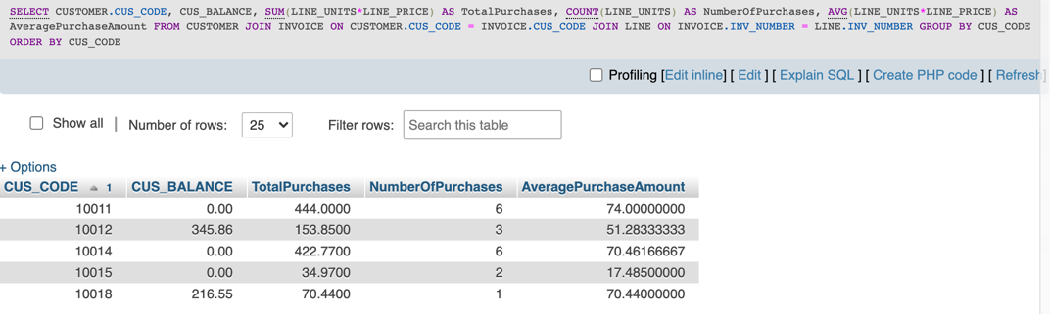ORDER BY CUS_CODE;

1. Create a query to produce the total purchase per invoice, generating the results shown in Figure P7.16, sorted by invoice number. The invoice total is the sum of the product purchases in the LINE that corresponds to the INVOICE.

SELECT INVOICE.INV_NUMBER, SUM(LINE_UNITS*LINE_PRICE) AS InvoiceTotal

FROM INVOICE JOIN LINE ON INVOICE.INV_NUMBER = LINE.INV_NUMBER

GROUP BY INV_NUMBER

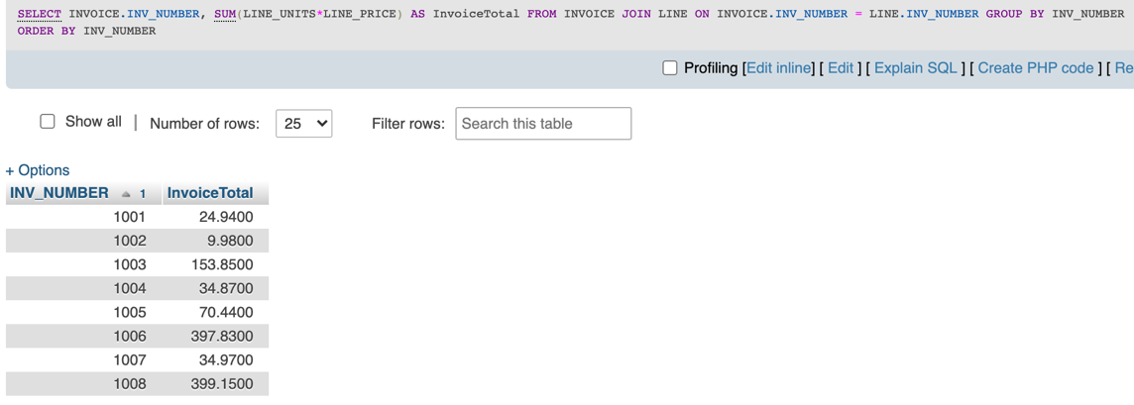ORDER BY INV_NUMBER;

1. Use a query to show the invoices and invoice totals in FigureP7.17. Sort the results by customer code and then by invoice number.

SELECT CUS_CODE, INVOICE.INV_NUMBER, SUM(LINE_UNITS*LINE_PRICE) AS InvoiceTotal

FROM INVOICE JOIN LINE ON INVOICE.INV_NUMBER = LINE.INV_NUMBER

GROUP BY INV_NUMBER

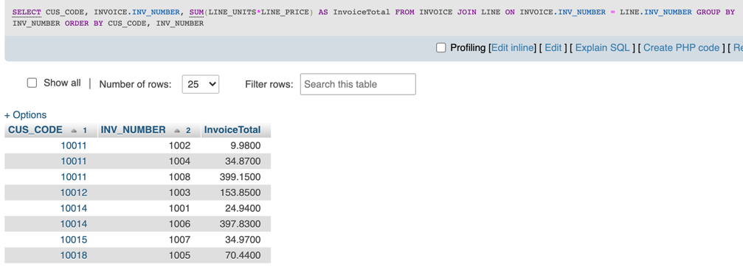ORDER BY CUS_CODE, INV_NUMBER;

1. Write a query to produce the number of invoices and the total purchase amounts by customer, using the output shown in Figure P7.18 as your guide. Note the results are sorted by customer code. (Compare this summary to the results shown in Problem 17.)

SELECT CUS_CODE, COUNT(DISTINCT LINE.INV_NUMBER) AS NumberOfInvoices, SUM(LINE_UNITS*LINE_PRICE) AS TotalCustomerPurchase

FROM INVOICE JOIN LINE ON INVOICE.INV_NUMBER = LINE.INV_NUMBER

GROUP BY CUS_CODE

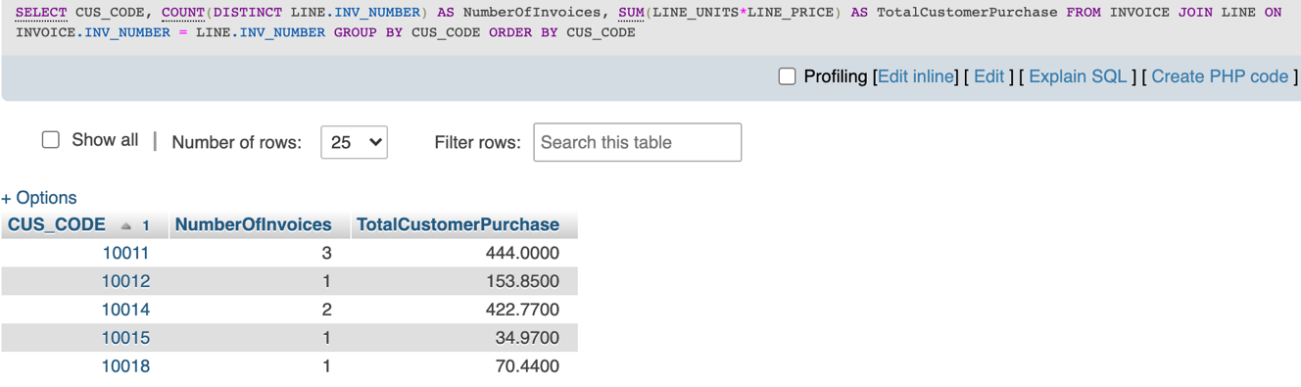ORDER BY CUS_CODE;

1. Write a query to generate the total number of invoices, the invoice total for all of the invoices, the smallest of the customer purchase amounts, the largest of the customer purchase amounts, and the average of all the customer purchase amounts. Your out- put must match Figure P7.19.

SELECT SUM(TI) AS TotalInvoices, SUM(TS) AS TotalSales, MIN(TS) AS MinimumCustomerPurchase, MAX(TS) AS MaximumCustomerPurchase, AVG(TS) AS AverageCustomerPurchase

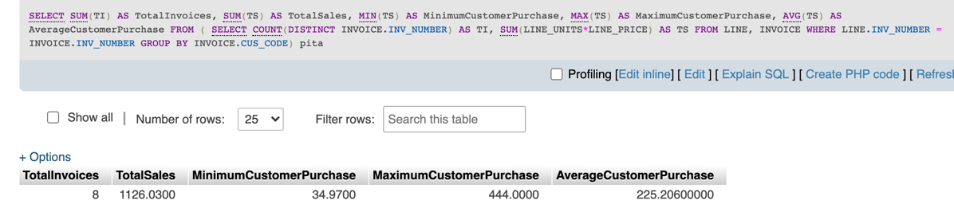FROM ( SELECT COUNT(DISTINCT INVOICE.INV_NUMBER) AS TI, SUM(LINE_UNITS*LINE_PRICE) AS TS FROM LINE, INVOICE WHERE LINE.INV_NUMBER = INVOICE.INV_NUMBER GROUP BY INVOICE.CUS_CODE) pita;

1. List the balances of customers who have made purchases during the current invoice cycle—that is, for the customers who appear in the INVOICE table. The results of this query are shown in Figure P7.20, sorted by customer code.

SELECT INVOICE.CUS_CODE, CUS_BALANCE

FROM INVOICE JOIN CUSTOMER ON INVOICE.CUS_CODE = CUSTOMER.CUS_CODE

GROUP BY CUS_CODE

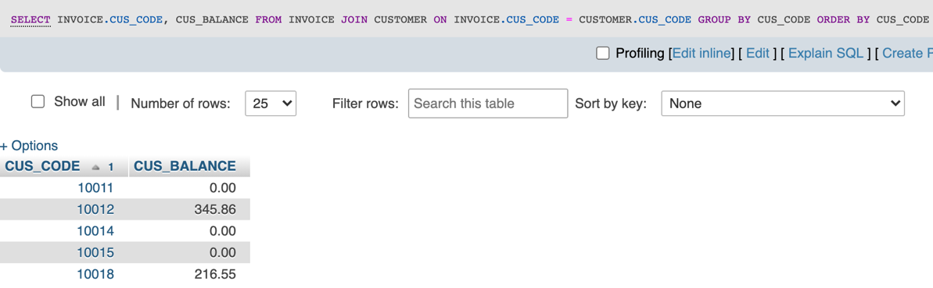ORDER BY CUS_CODE;